TAREA

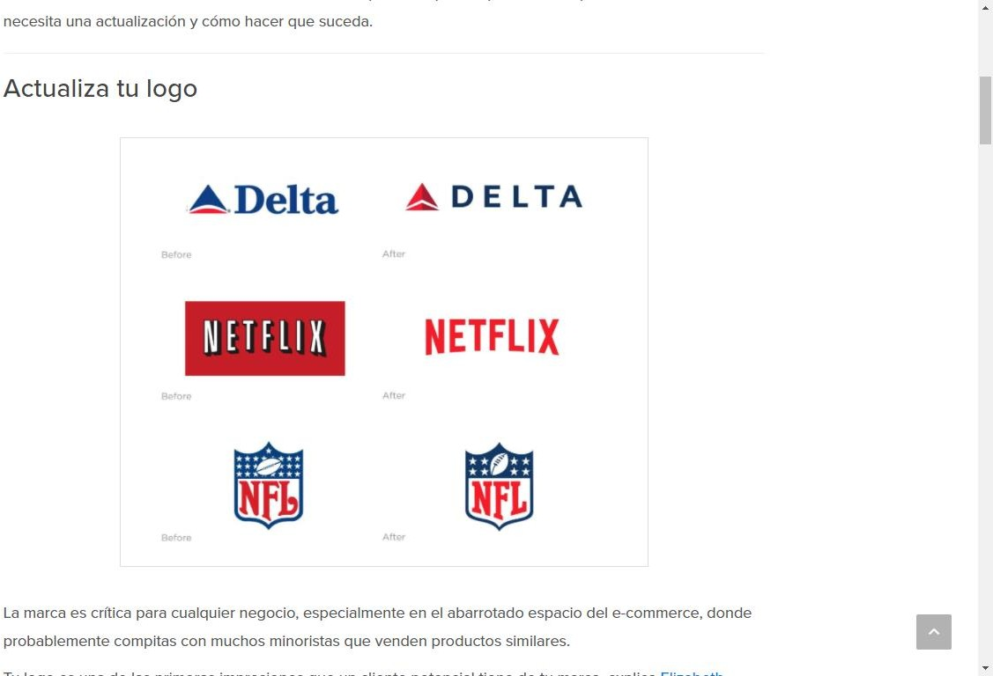

URL: <https://jumpseller.com.pe/learn/5-ways-to-do-a-brand-refresh-and-why-you-should/>

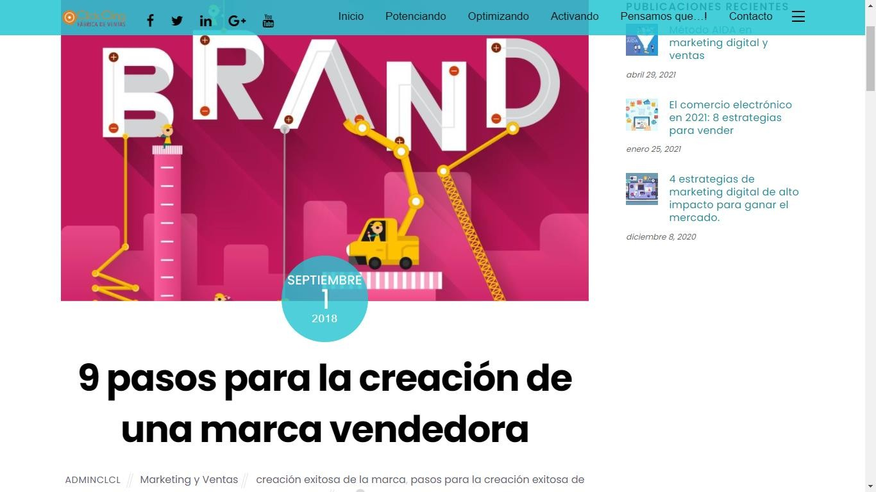

URL: <https://www.clickcling.com/9-pasos-para-la-creacion-exitosa-de-la-marca-2/>

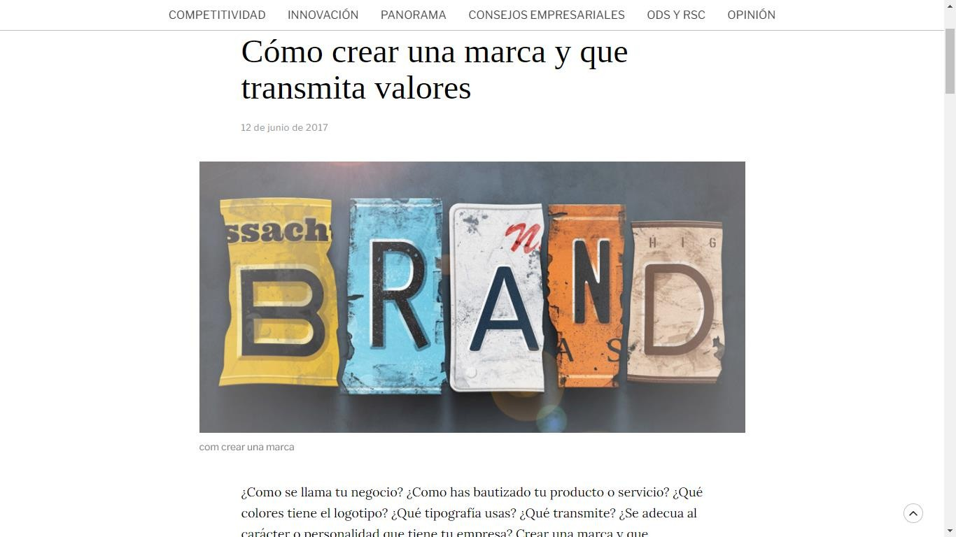

URL: <https://www.pimealdia.org/es/crear-marca-que-transmeti-valors/>

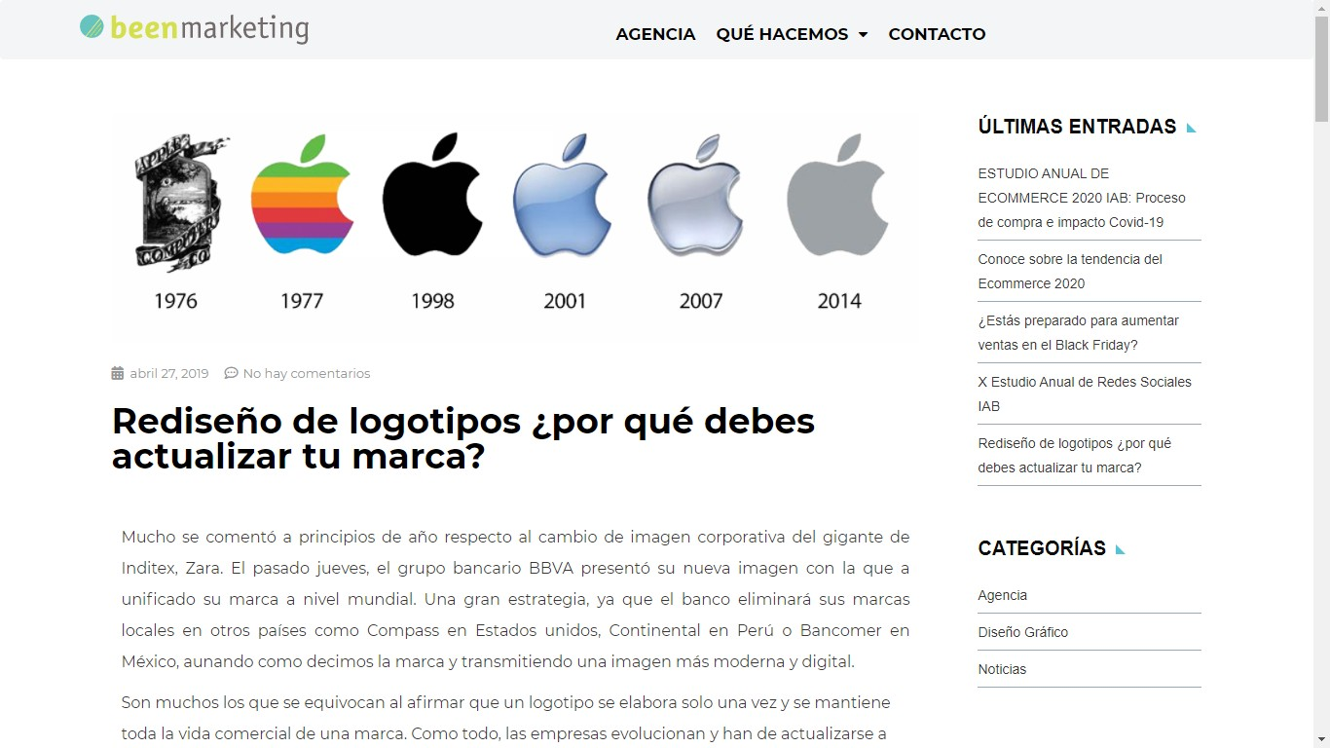

URL: <https://beenmarketing.com/rediseno-de-logotipos-por-que-debes-actualizar-tu-marca/>

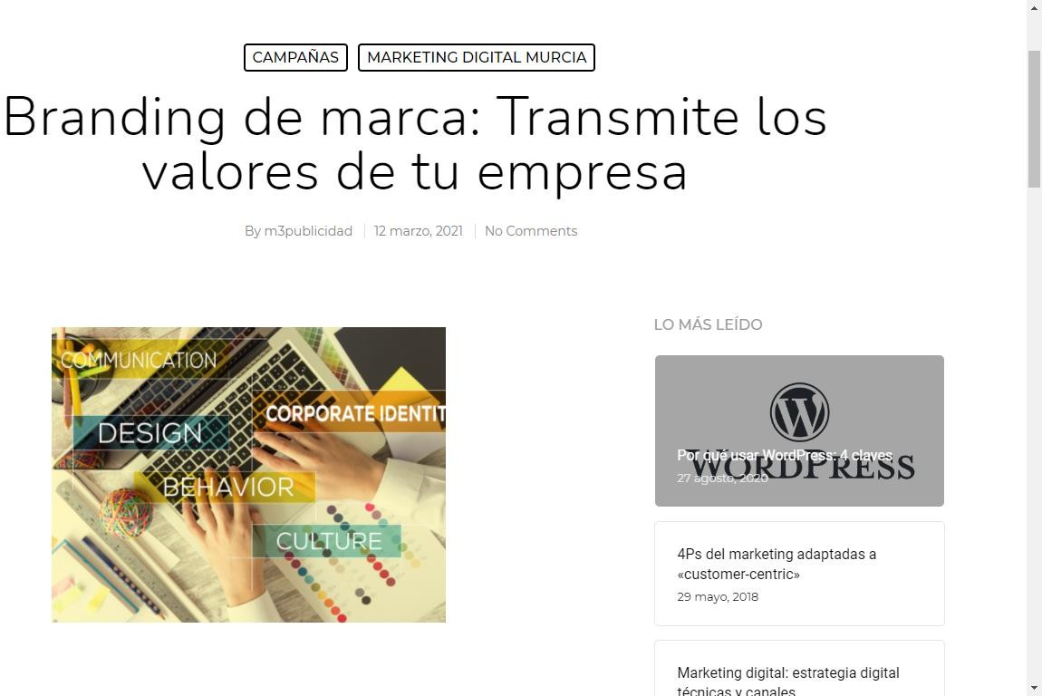

URL: <https://www.m3publicidad.es/branding-de-marca-transmites-los-valores-de-tu-marca/>

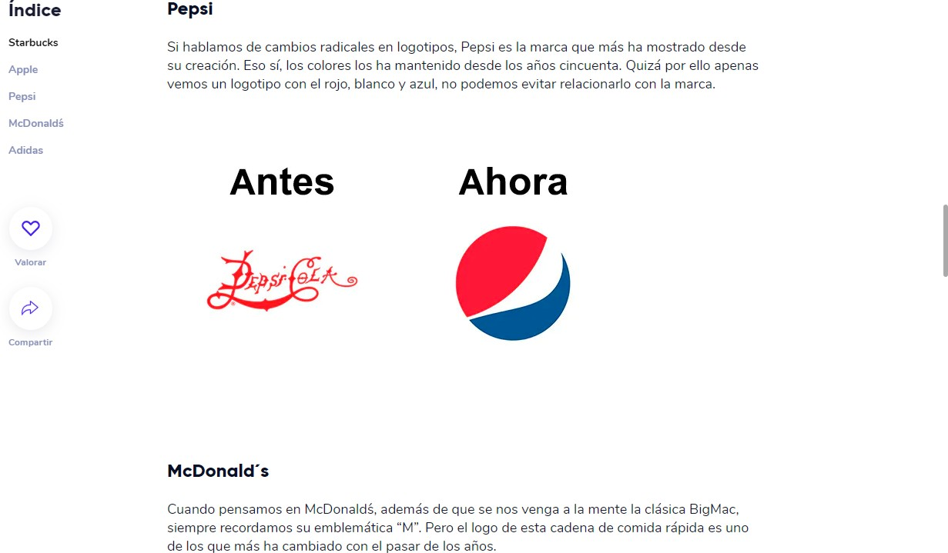

URL: [https://www.crehana.com/pe/blog/marketing-digital/5-logos-que-mas-cambiaron-a-lo-](https://www.crehana.com/pe/blog/marketing-digital/5-logos-que-mas-cambiaron-a-lo-largo-de-su-historia/) [largo-de-su-historia/](https://www.crehana.com/pe/blog/marketing-digital/5-logos-que-mas-cambiaron-a-lo-largo-de-su-historia/)

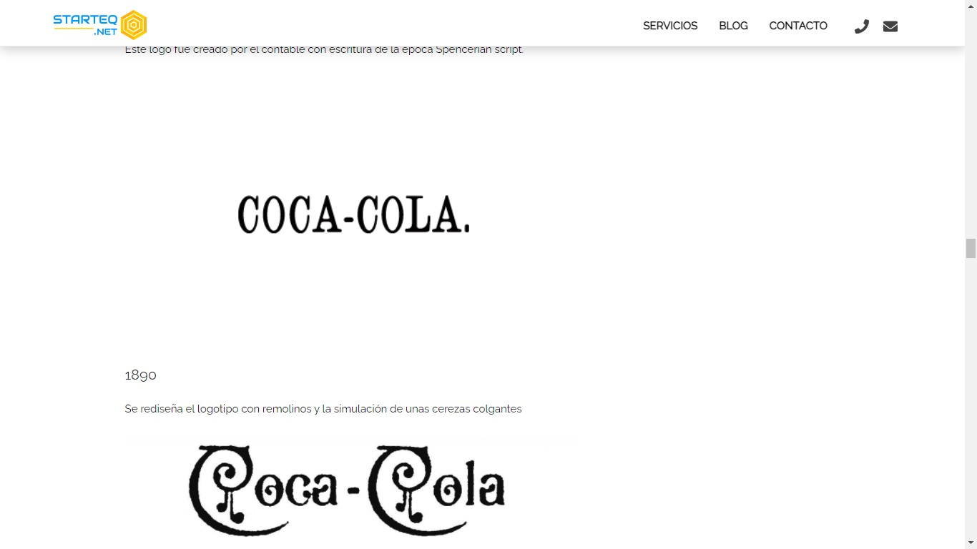

URL: <https://starteq.net/logos-en-el-tiempo/>